### **Test Cases**

#### **Test Case 1: Repeating Characters**

**Input**:

Hello

**Expected Output**:

The most frequent character is: 'l' with count: 2



#### **Test Case 2: No Repeating Characters**

**Input**:

abcd

**Expected output:**

No character repeats in the string.

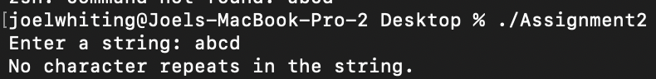

#### 

#### 

#### 

#### 

#### 

#### 

#### 

#### **Test Case 3: Empty String**

**Input**:

(blank space)

**Expected Output**:

No character repeats in the string.

